# Part 1

## Generate Service Principle for Terraform in Azure

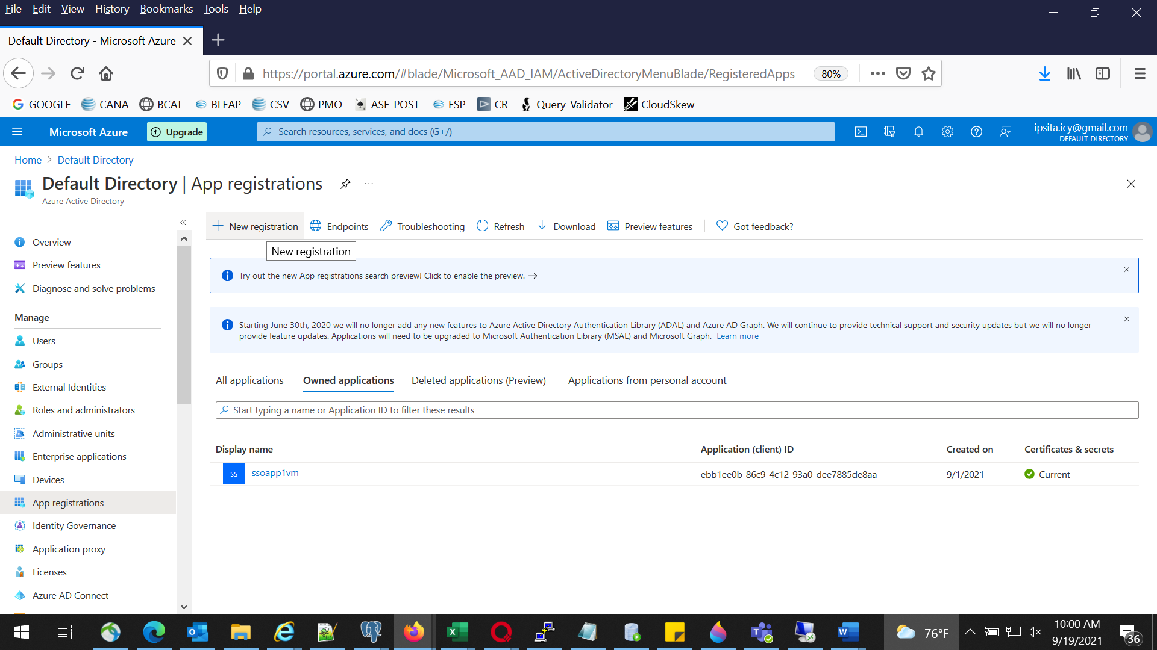

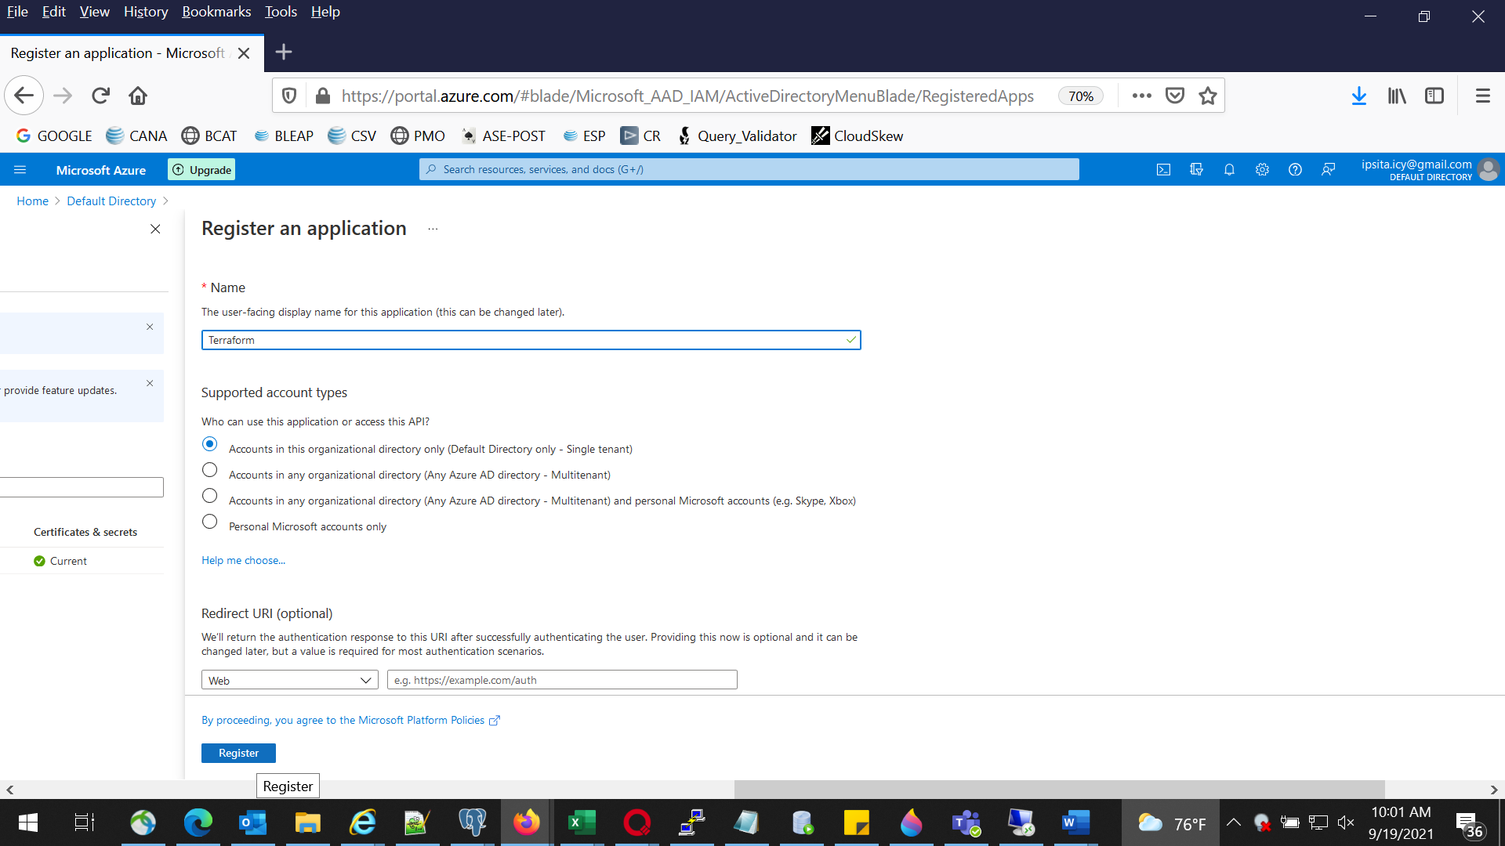

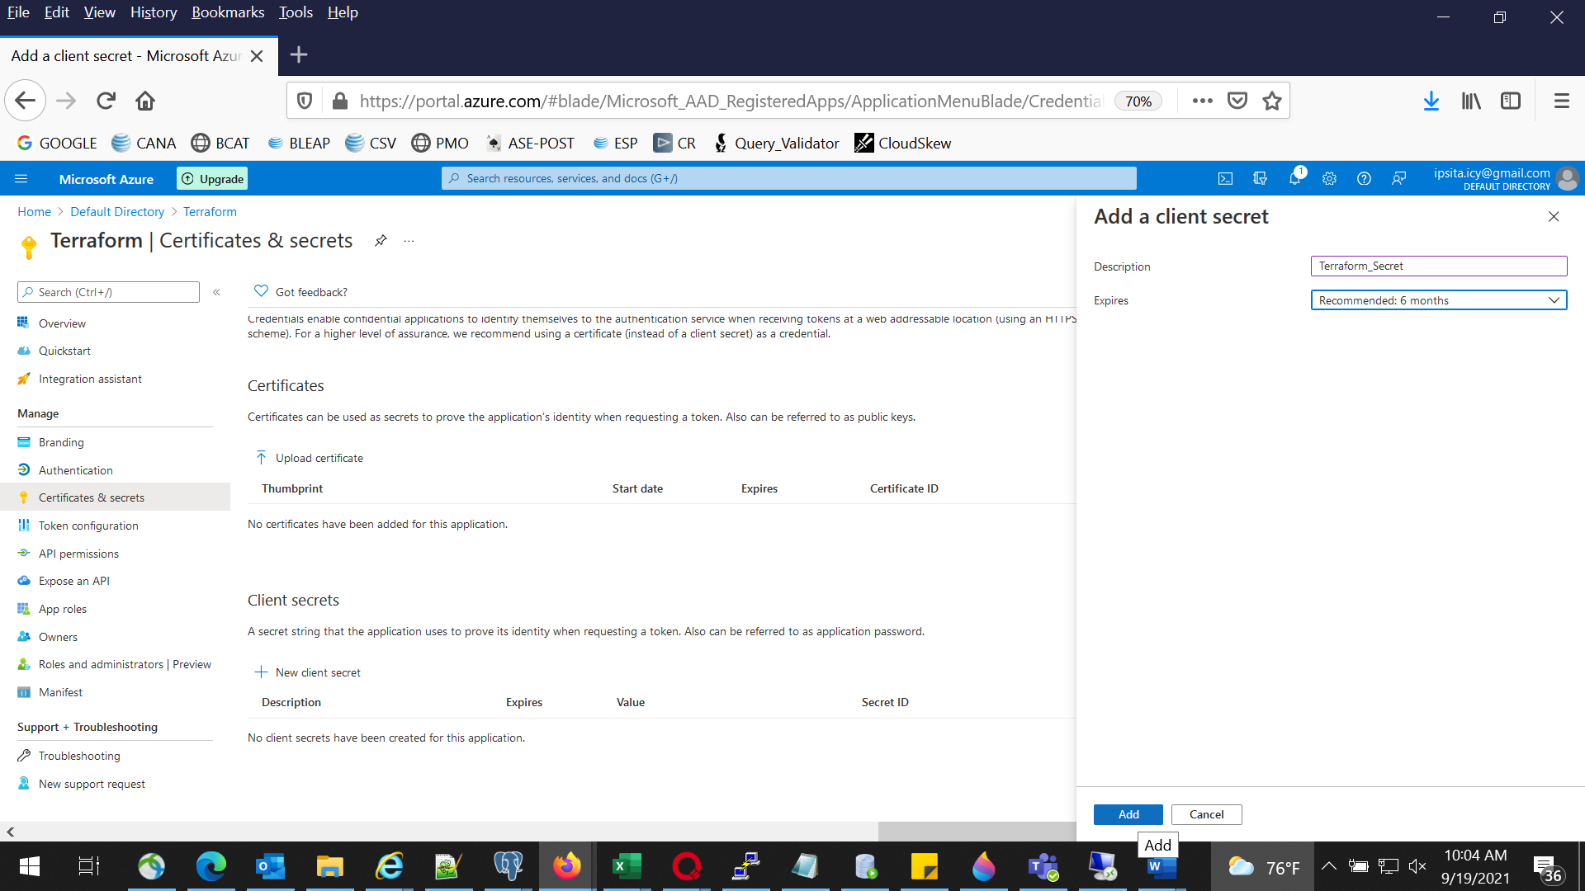

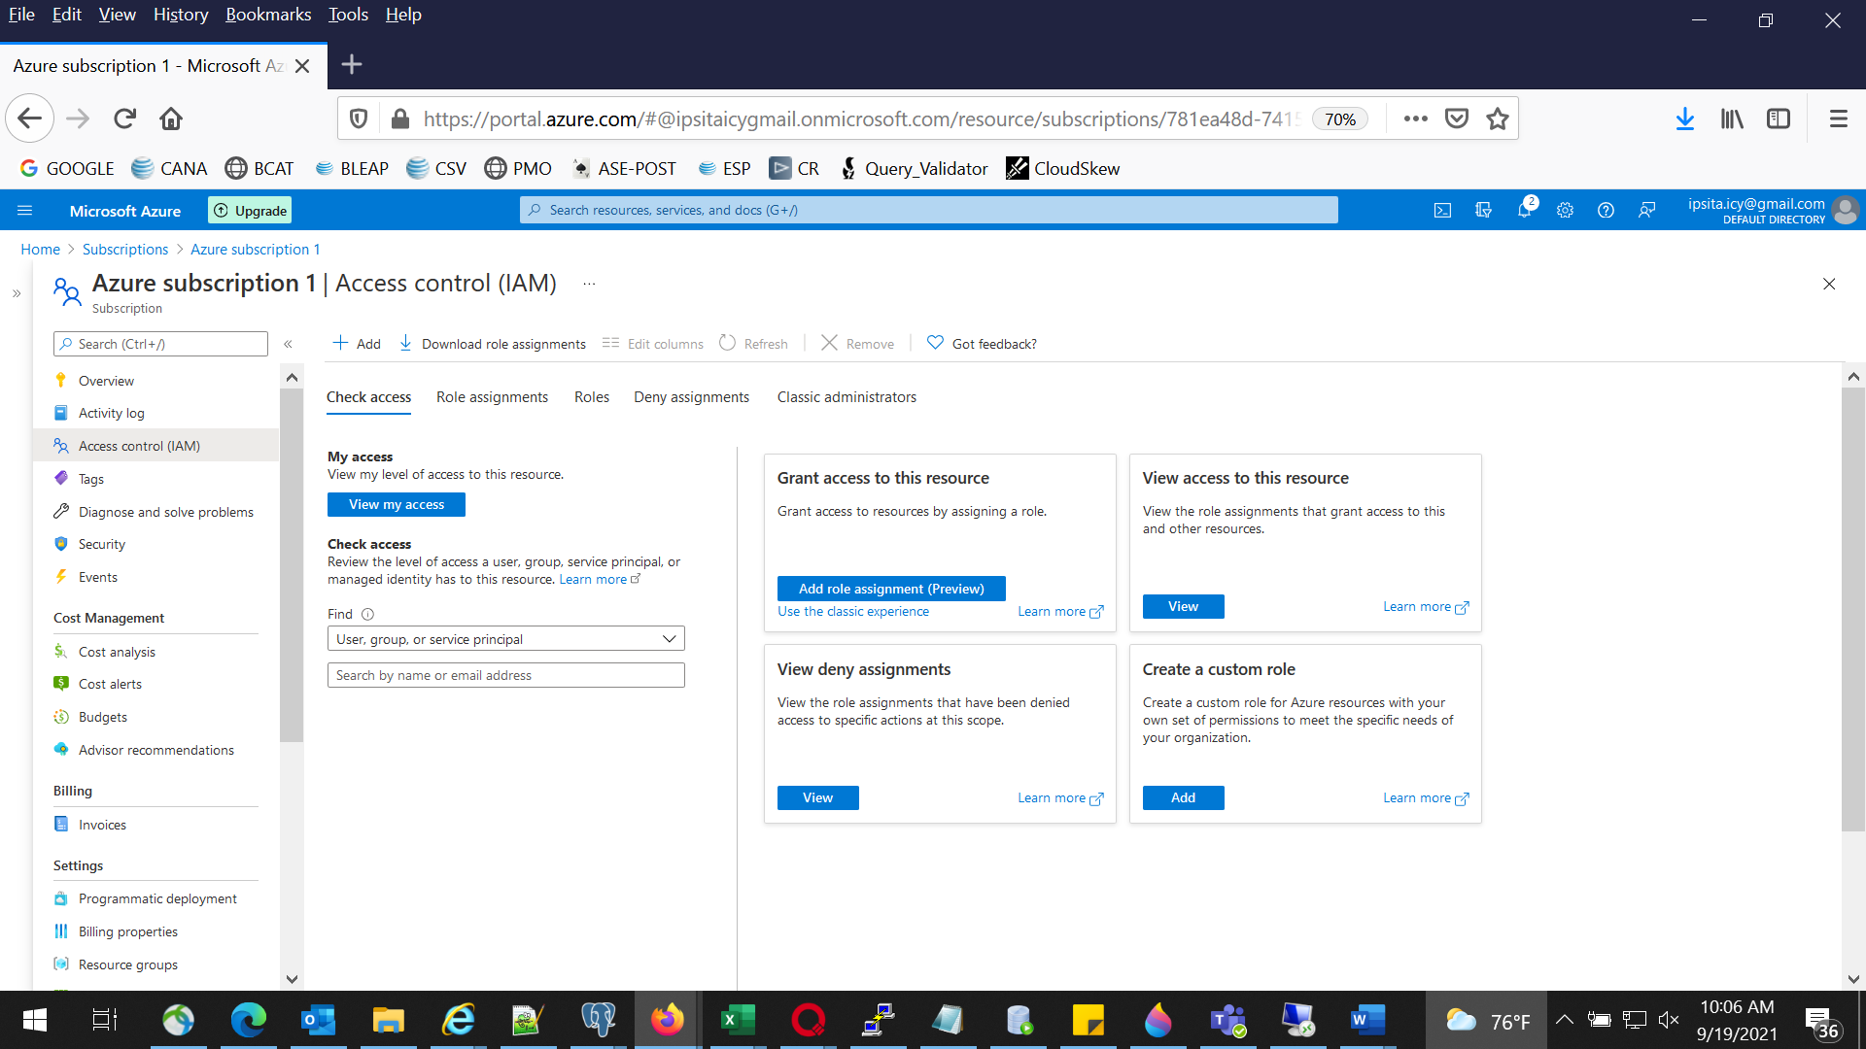

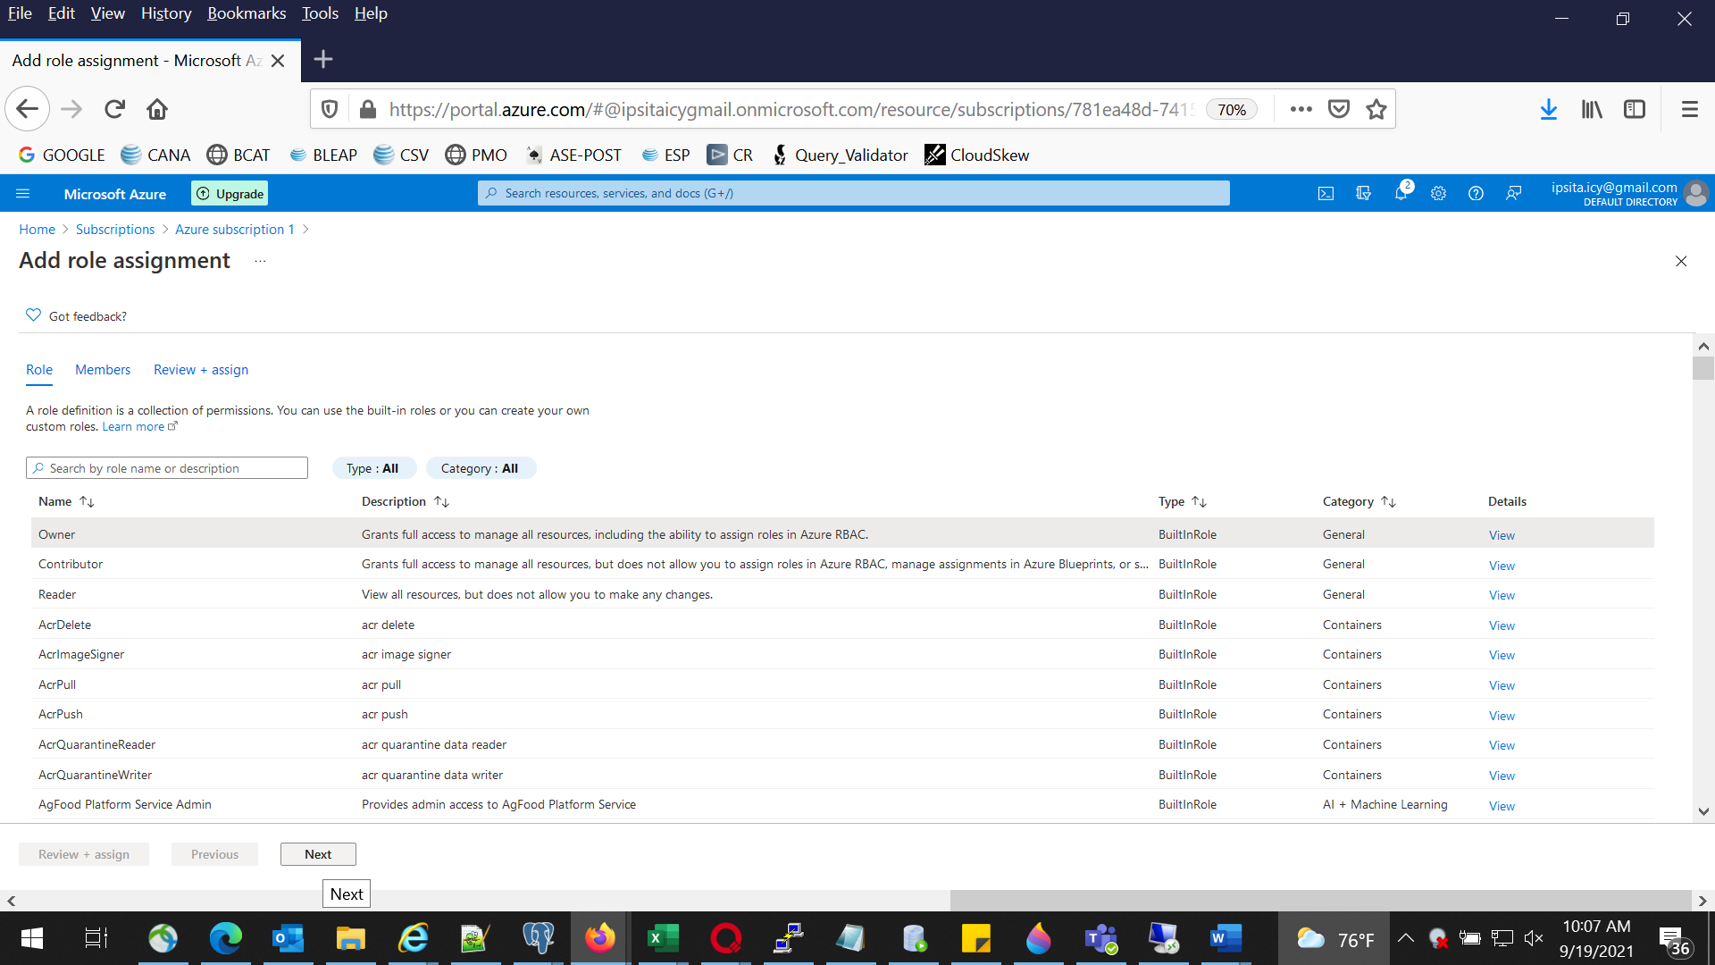

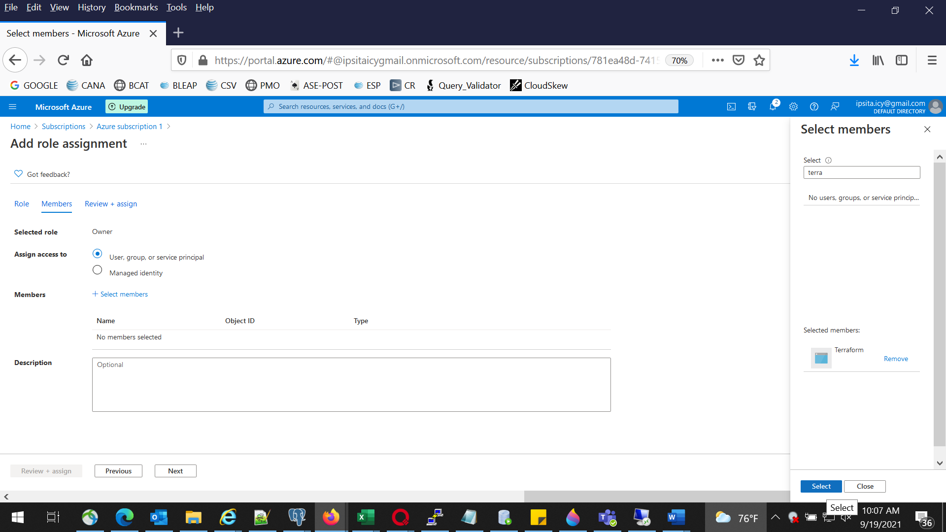

## Create required Vars.tf to create two VMs in Azure

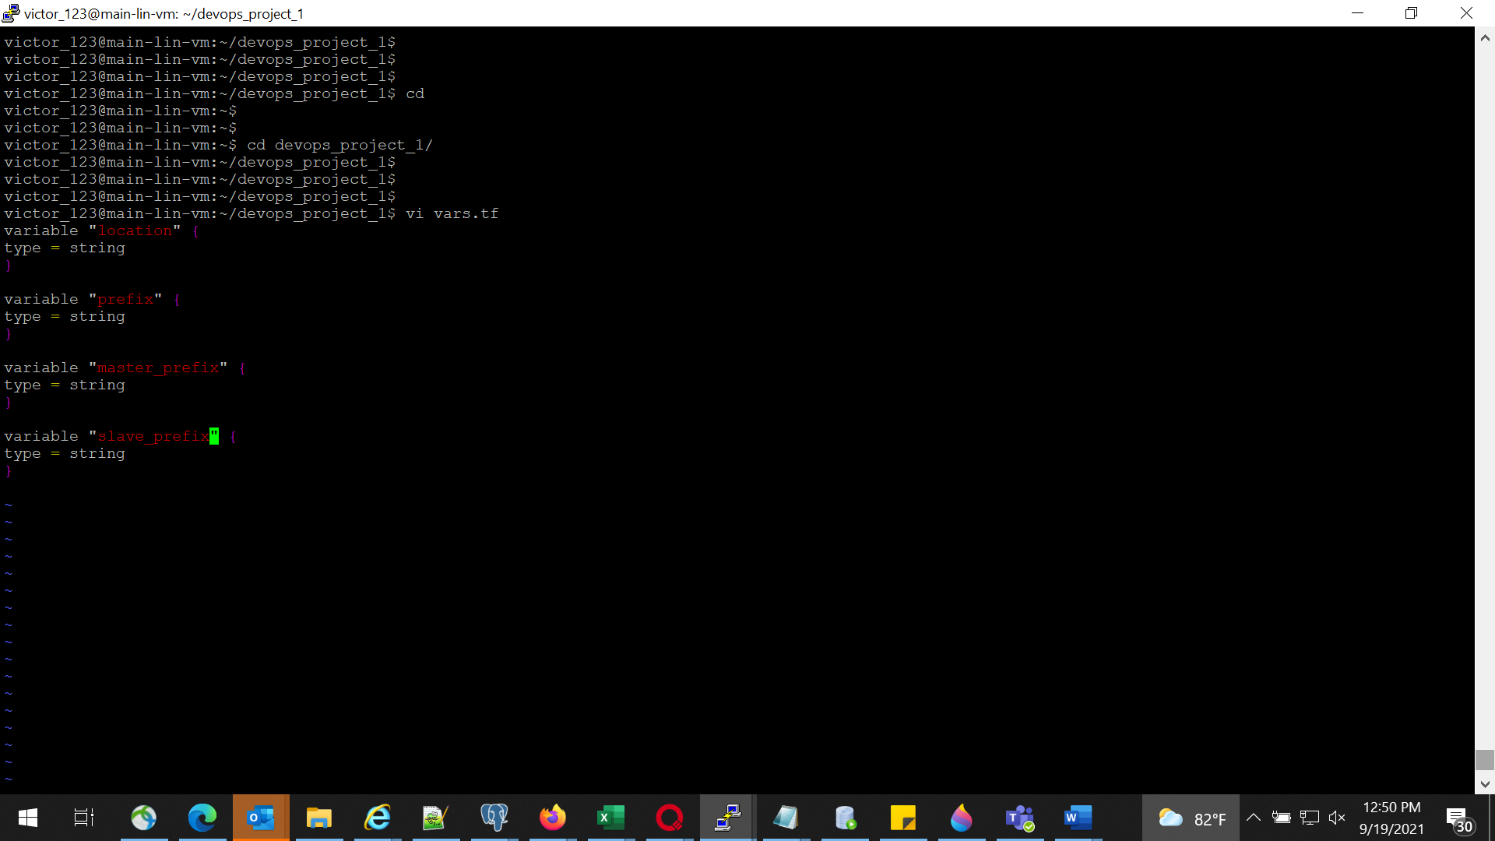

## Create required terraform.tfvars

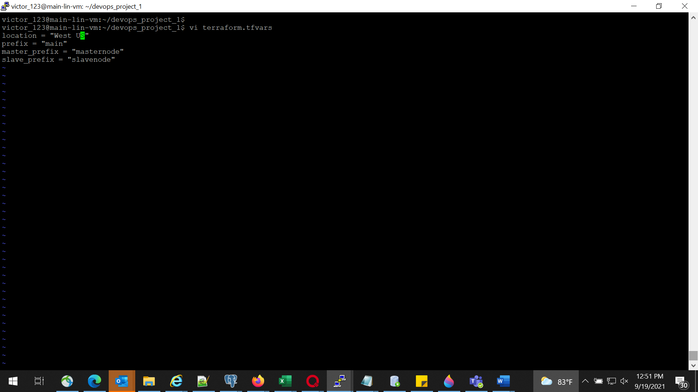

## Create main.tf to create two Linux VMs

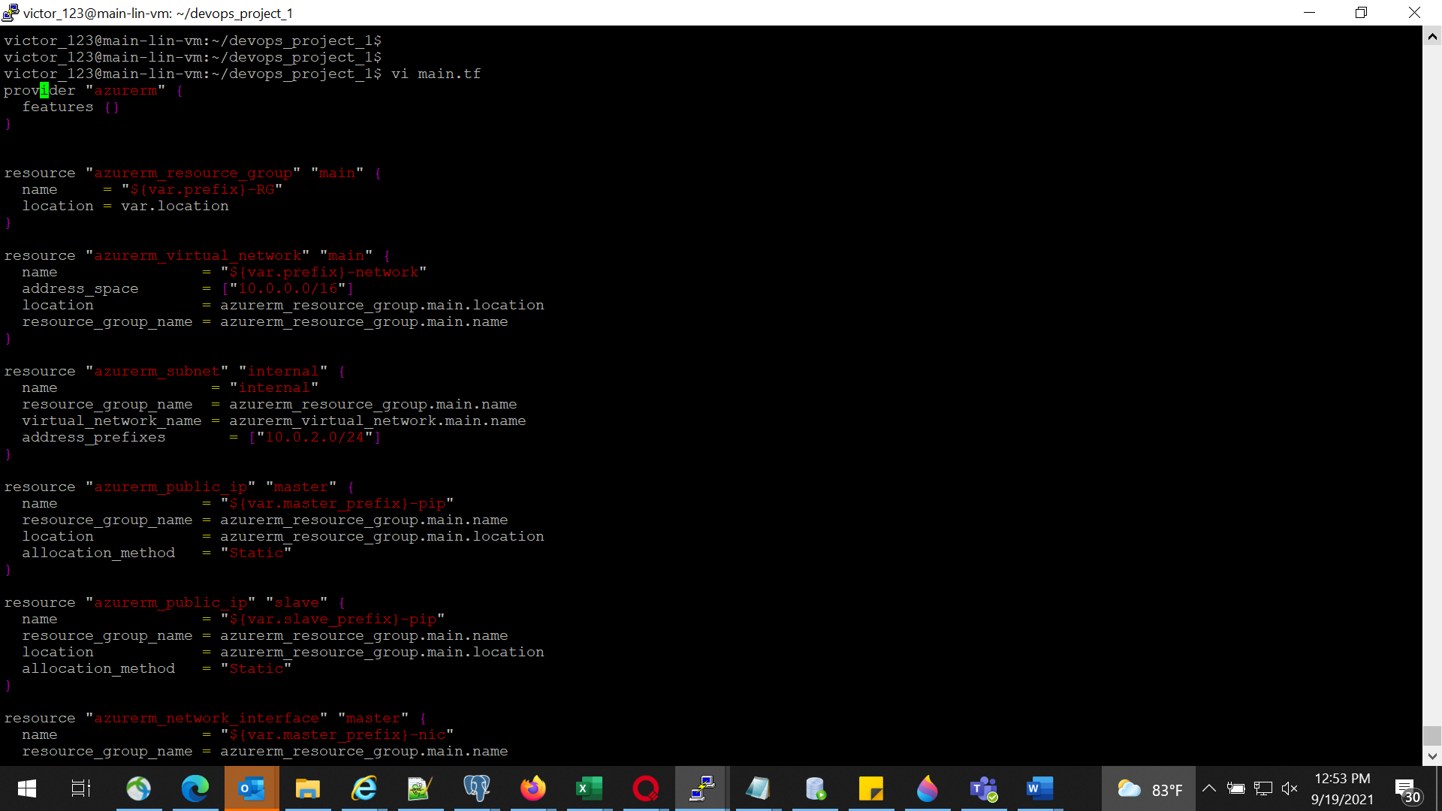

## Init,Plan and Apply Terraform Script

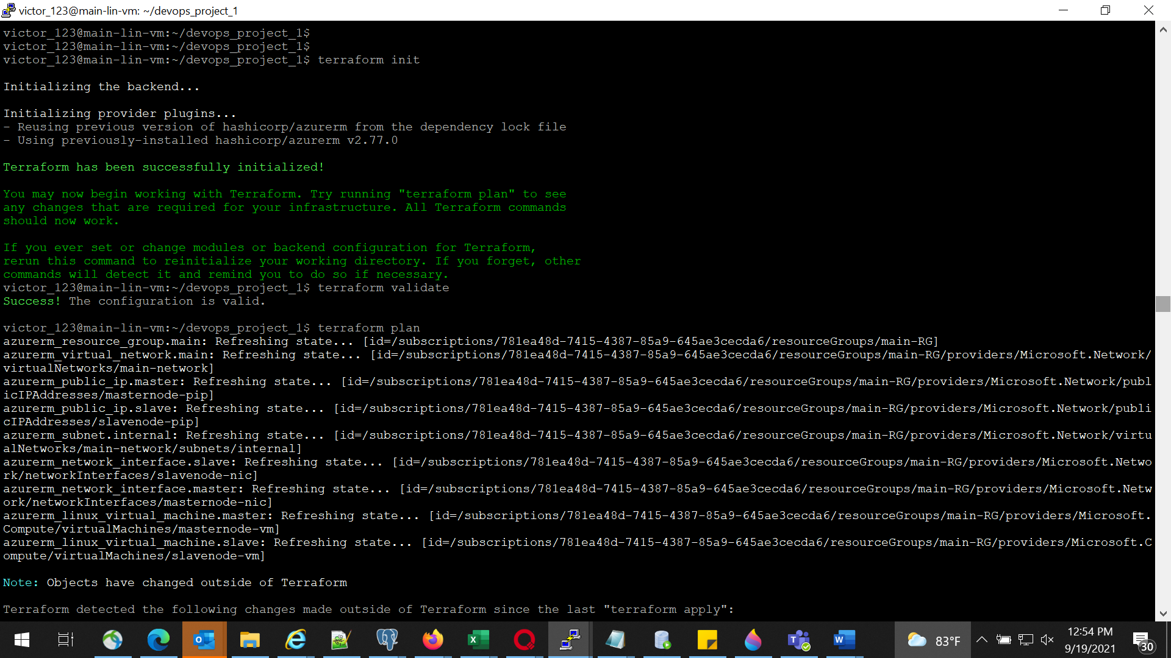

## Manually Start Jenkins and configure required Plug-ins and Master Slave Configuration

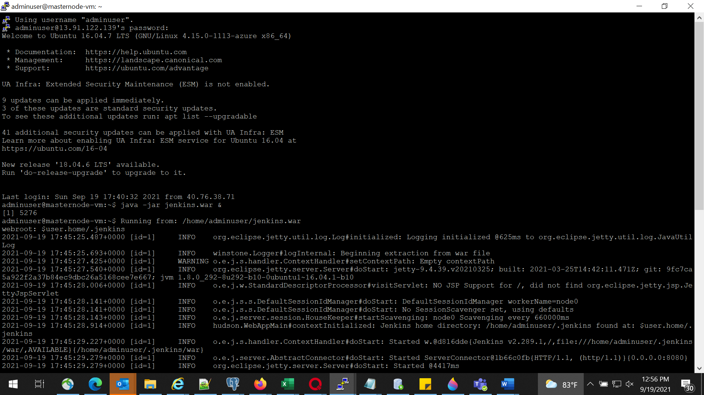

Plugin installation

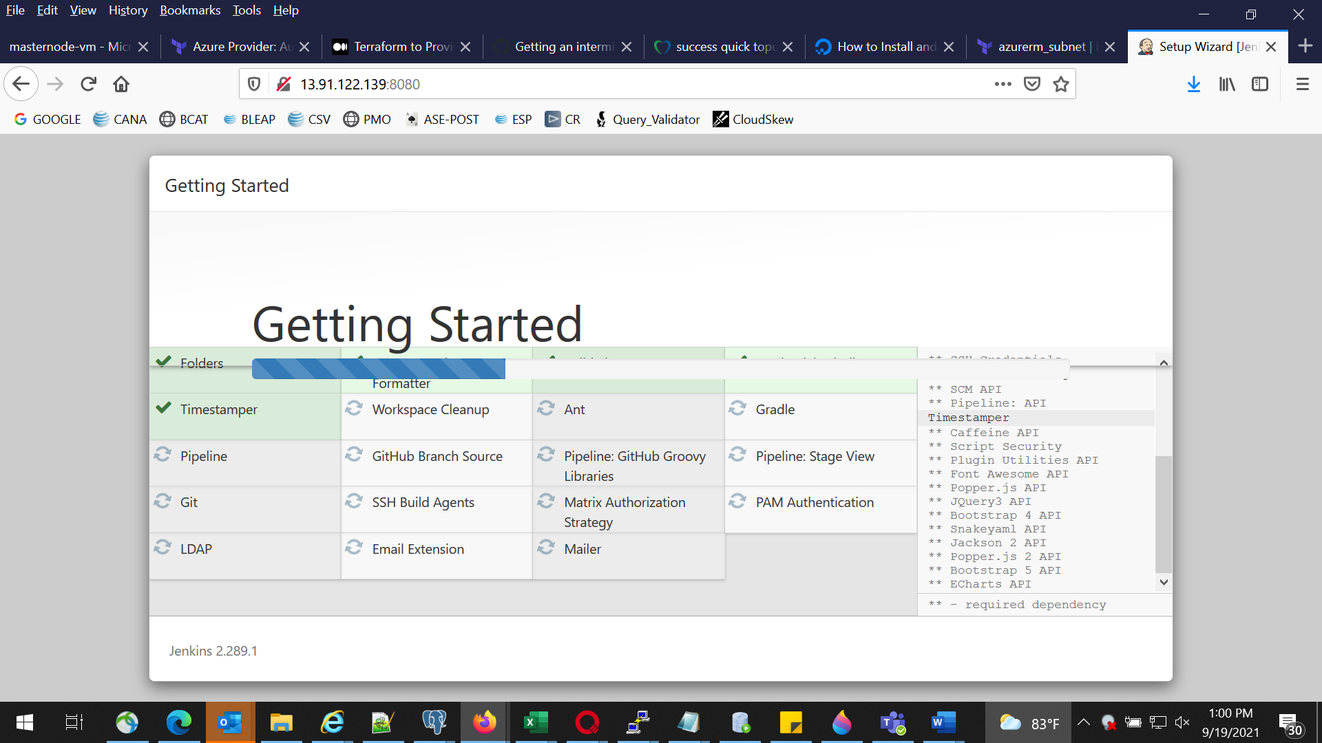

# Part 2 – Phase 1

## Create Maven Project with Archetype as web application in eclipse

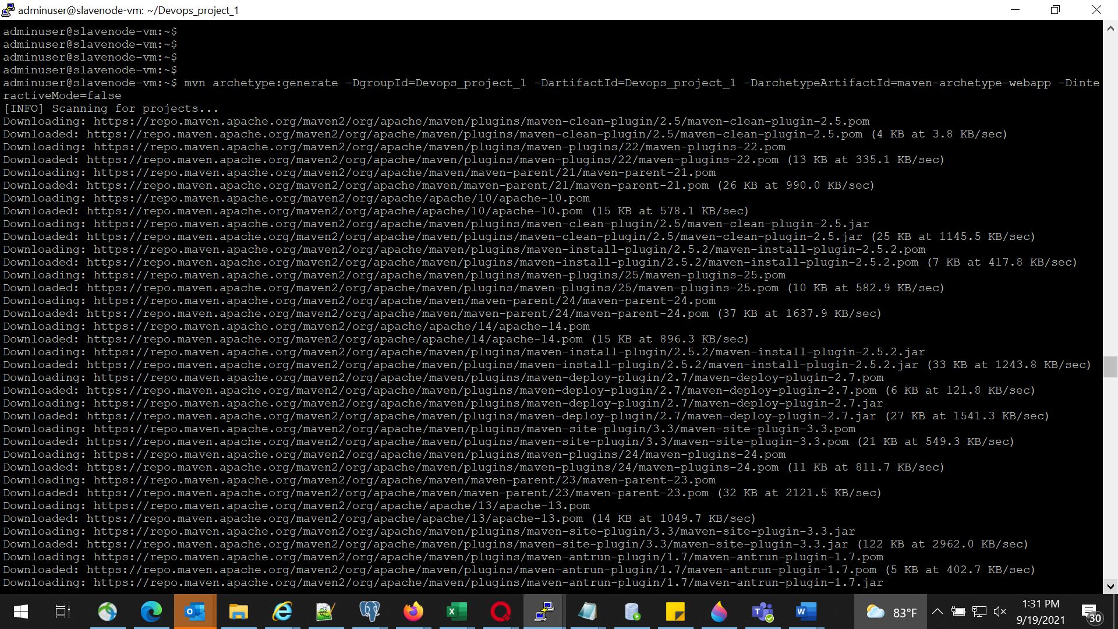

## Modify Index.jsp under src/main/webapp to display a custom message

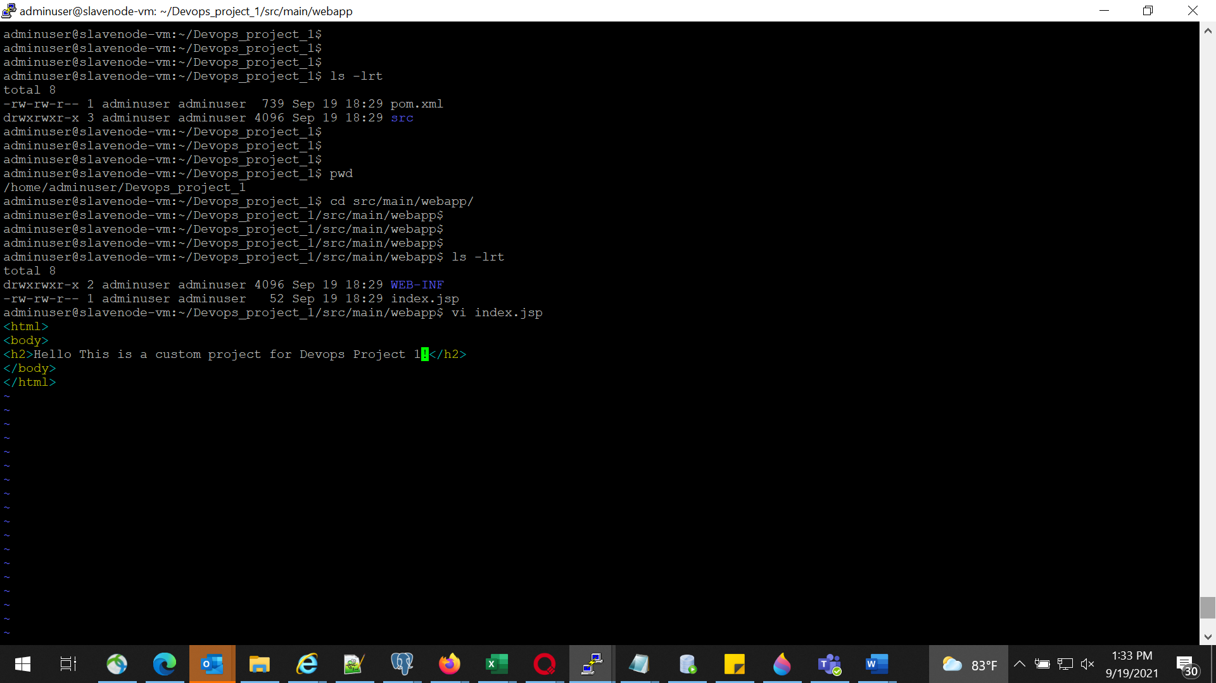

## Run Maven clean install in eclipse to check the build and check for .war file in target folder

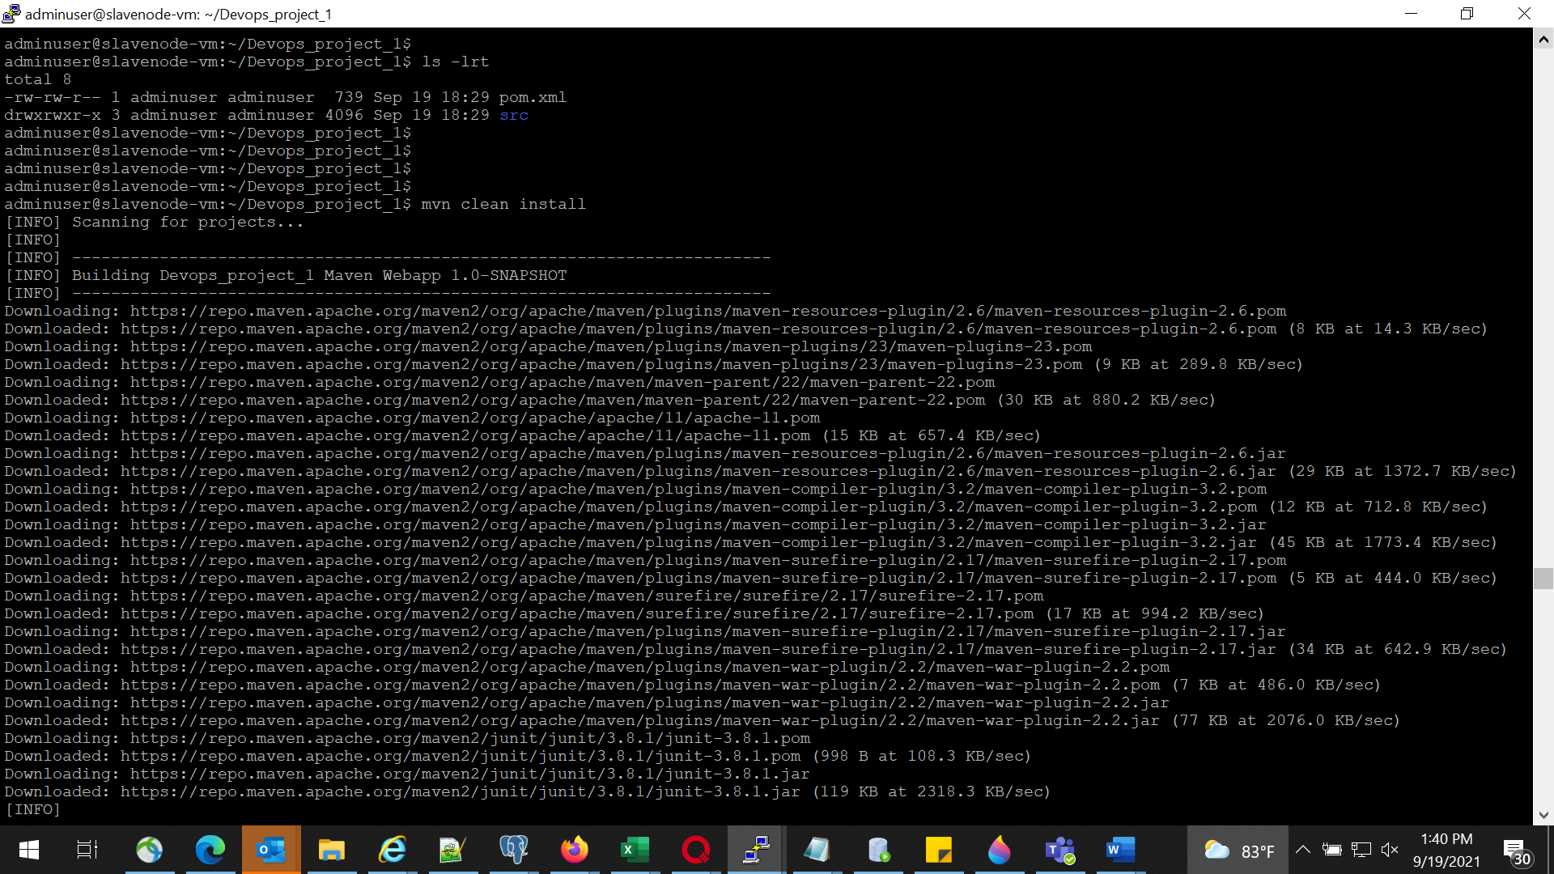

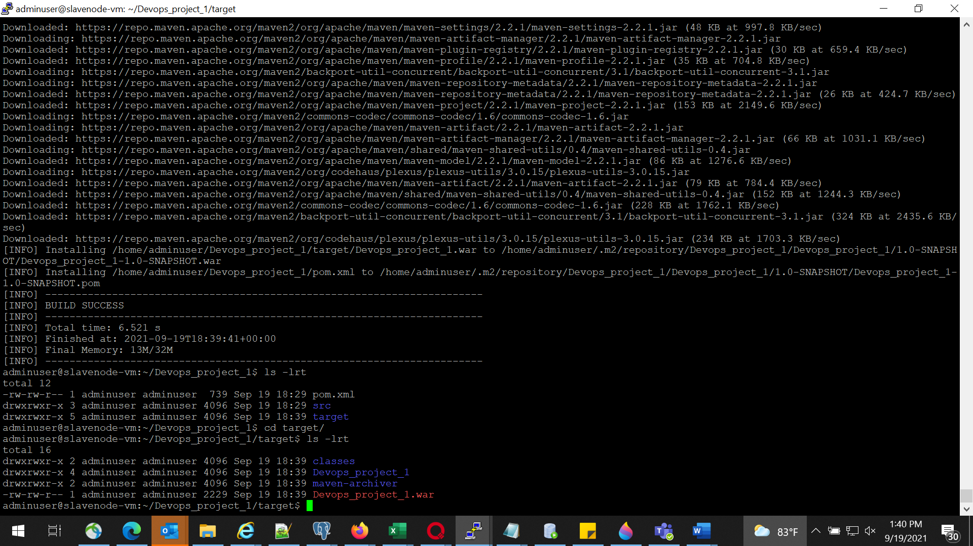

# Part 2 – Phase 2

## Generate Dockerfile under project folder of your app

## Modify FORM statement to use tomcat as base image

## Test the Dockerfile by running Docker build and create a container

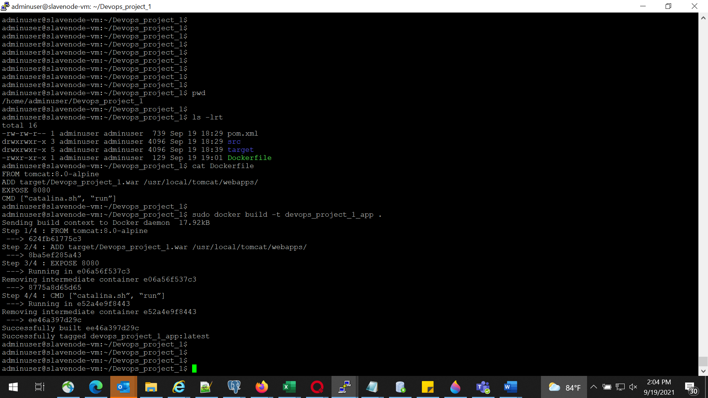

## Access the application from container and check it

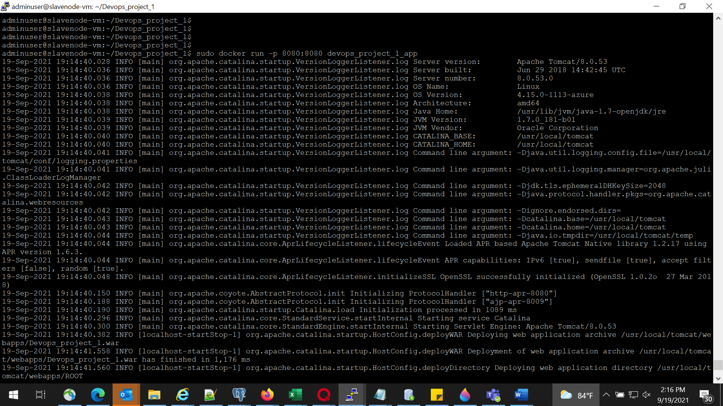

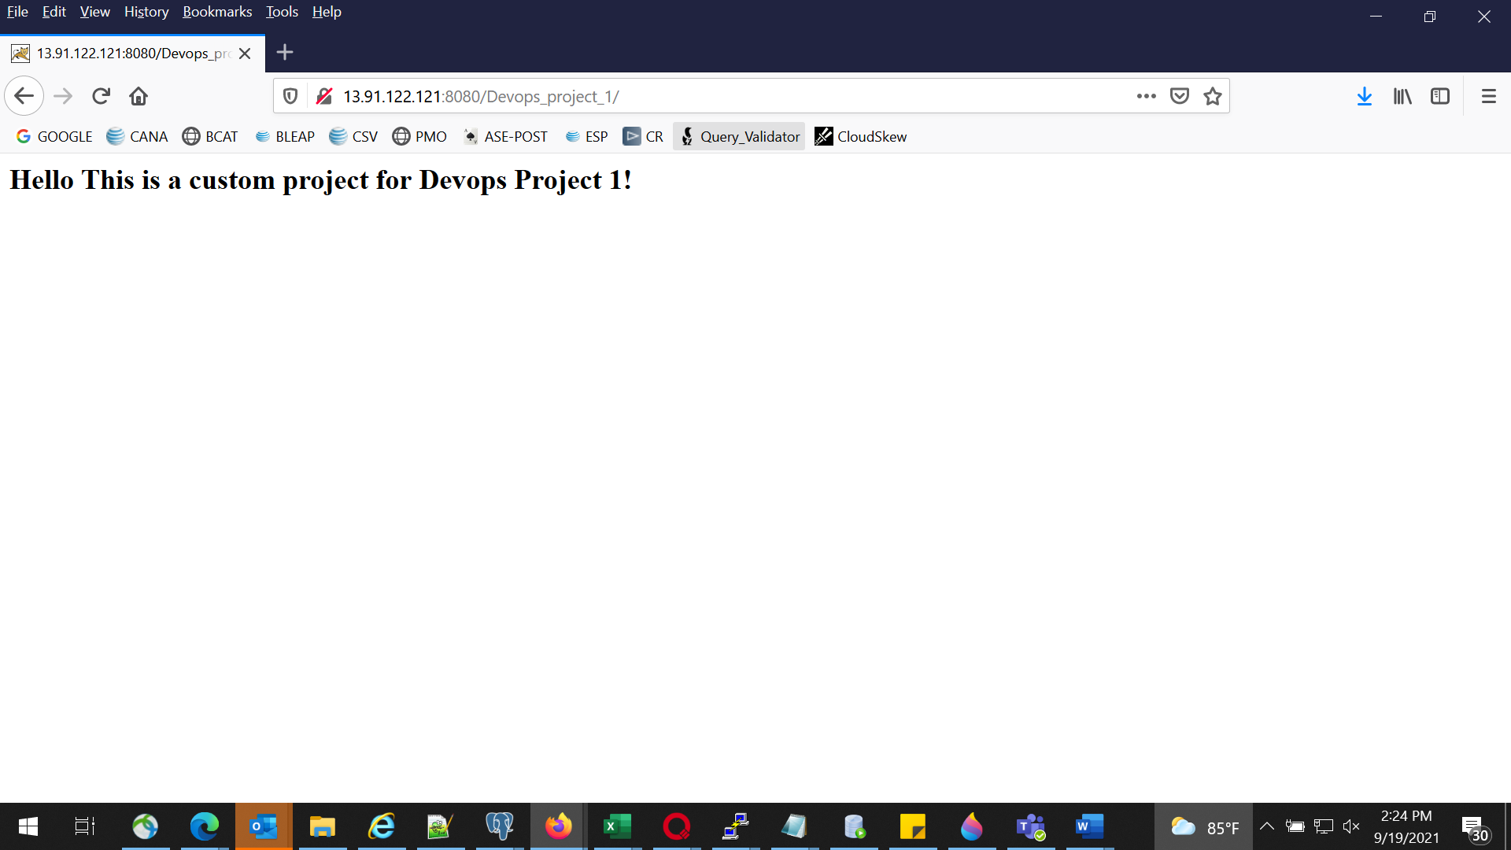

# Part 2 – Phase 3

## Create a github repository and copy repo URL

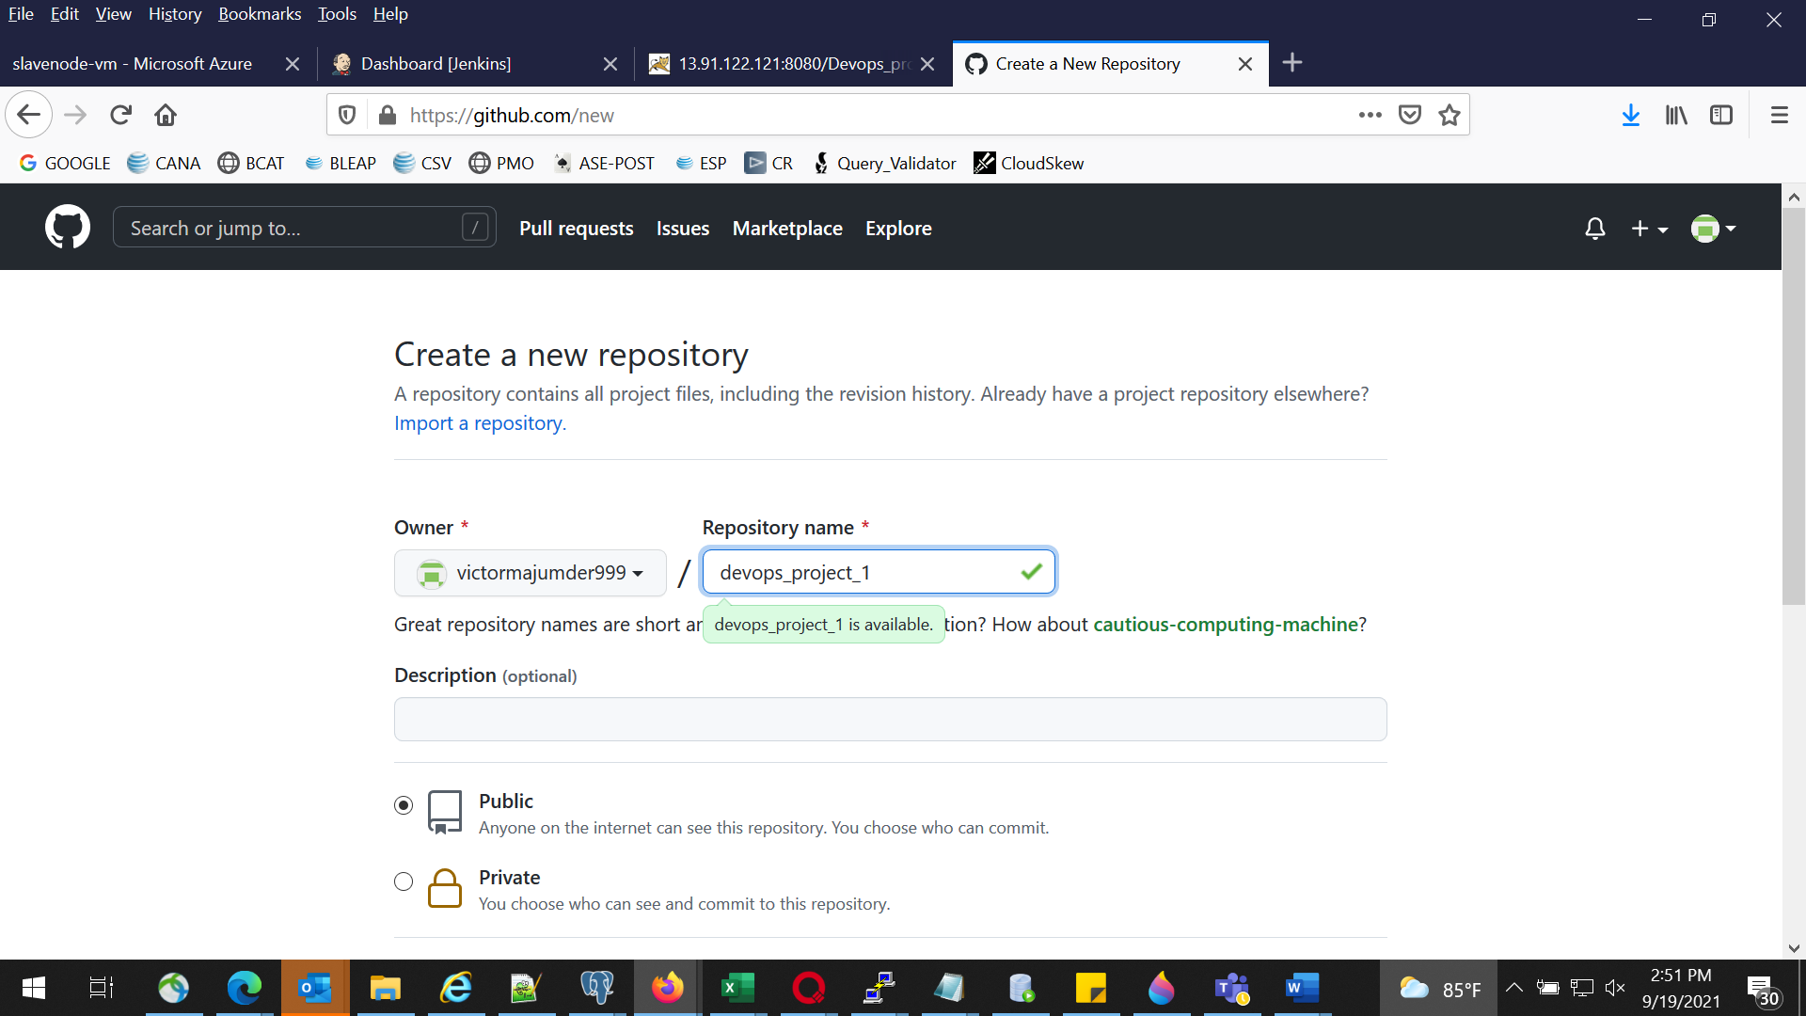

## In Eclipse convert the app in to a local repo from Team meanu share Project Option

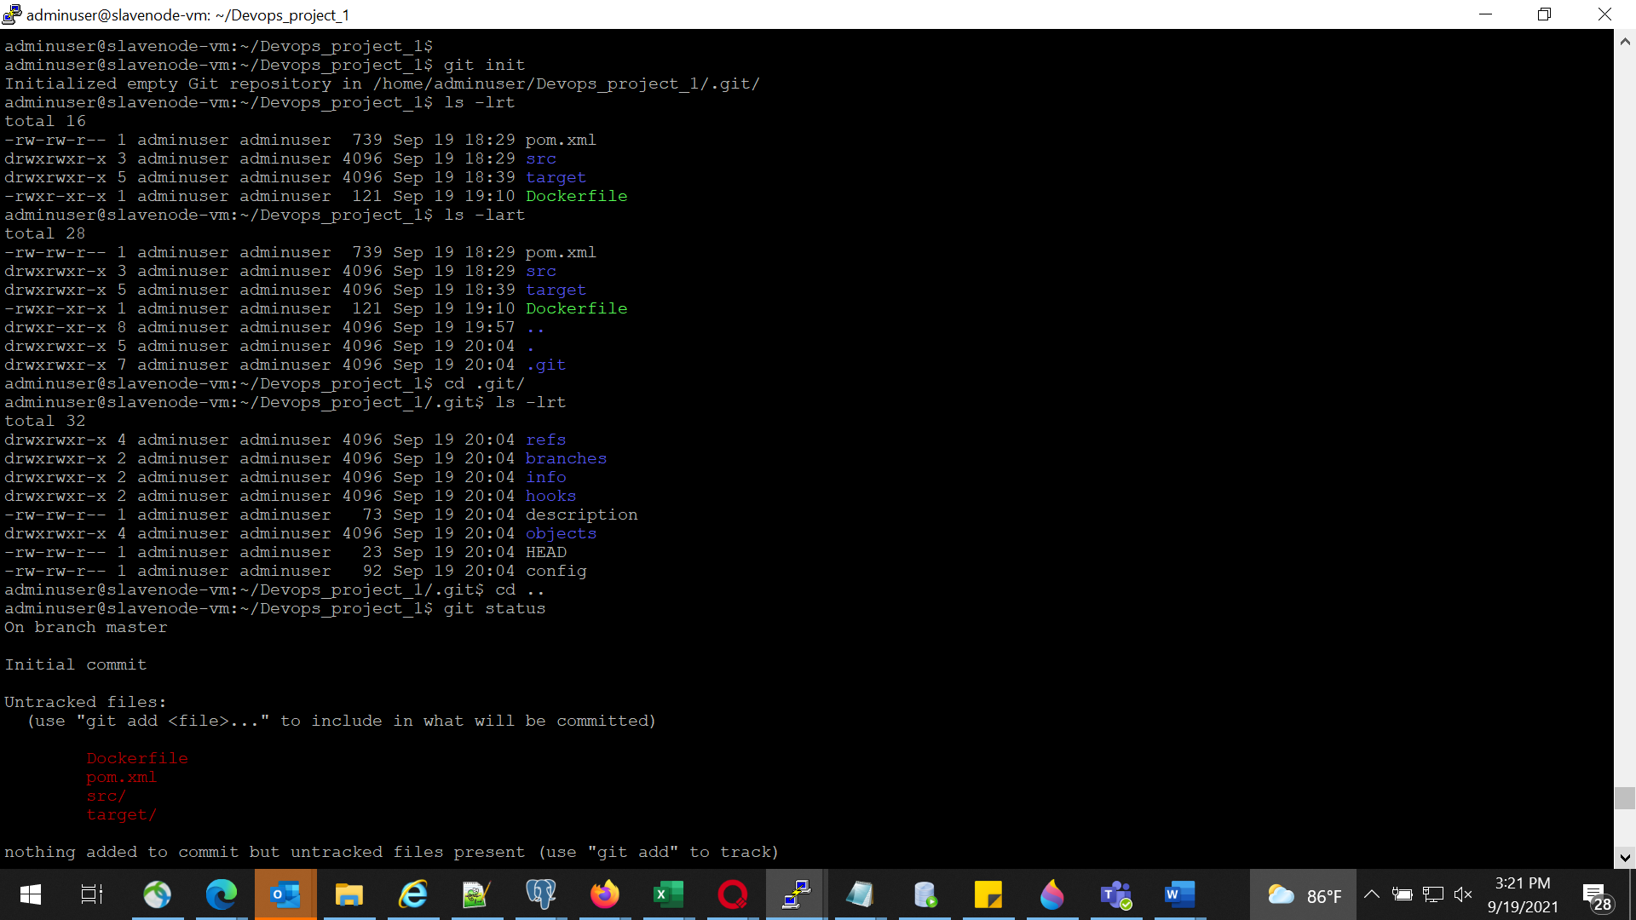

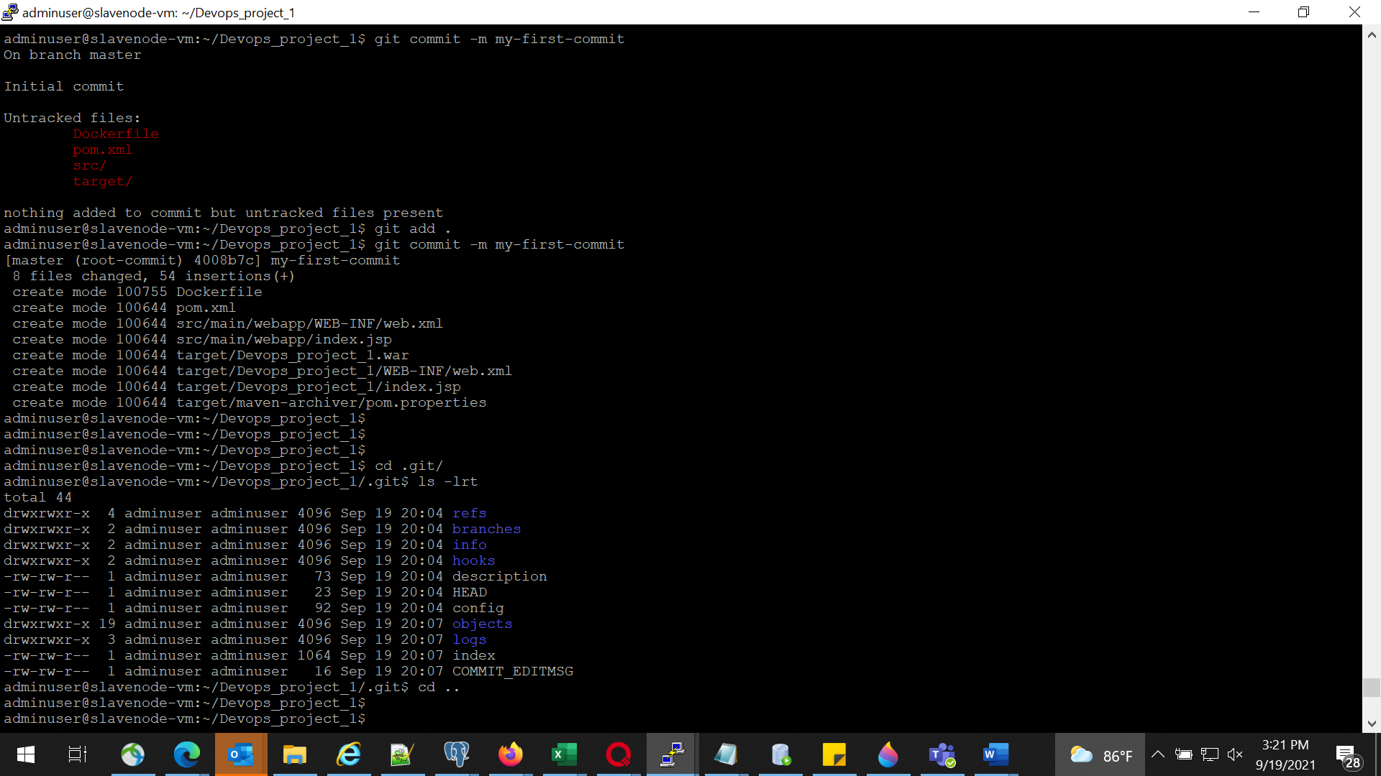

## Commit and Push the code to remote repo

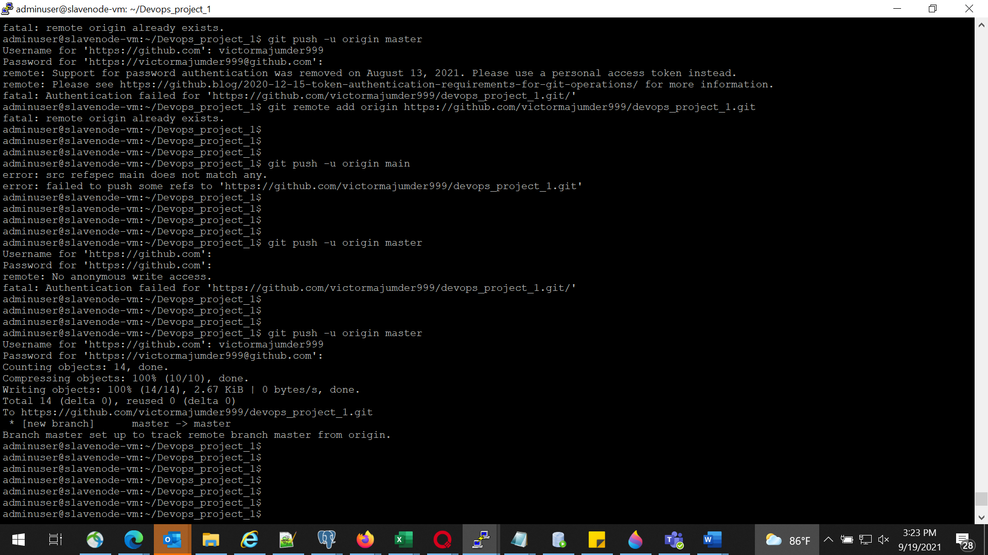

# Part 2 – Phase 4

## Modify Project index.jsp, Commit and Push to remote repo

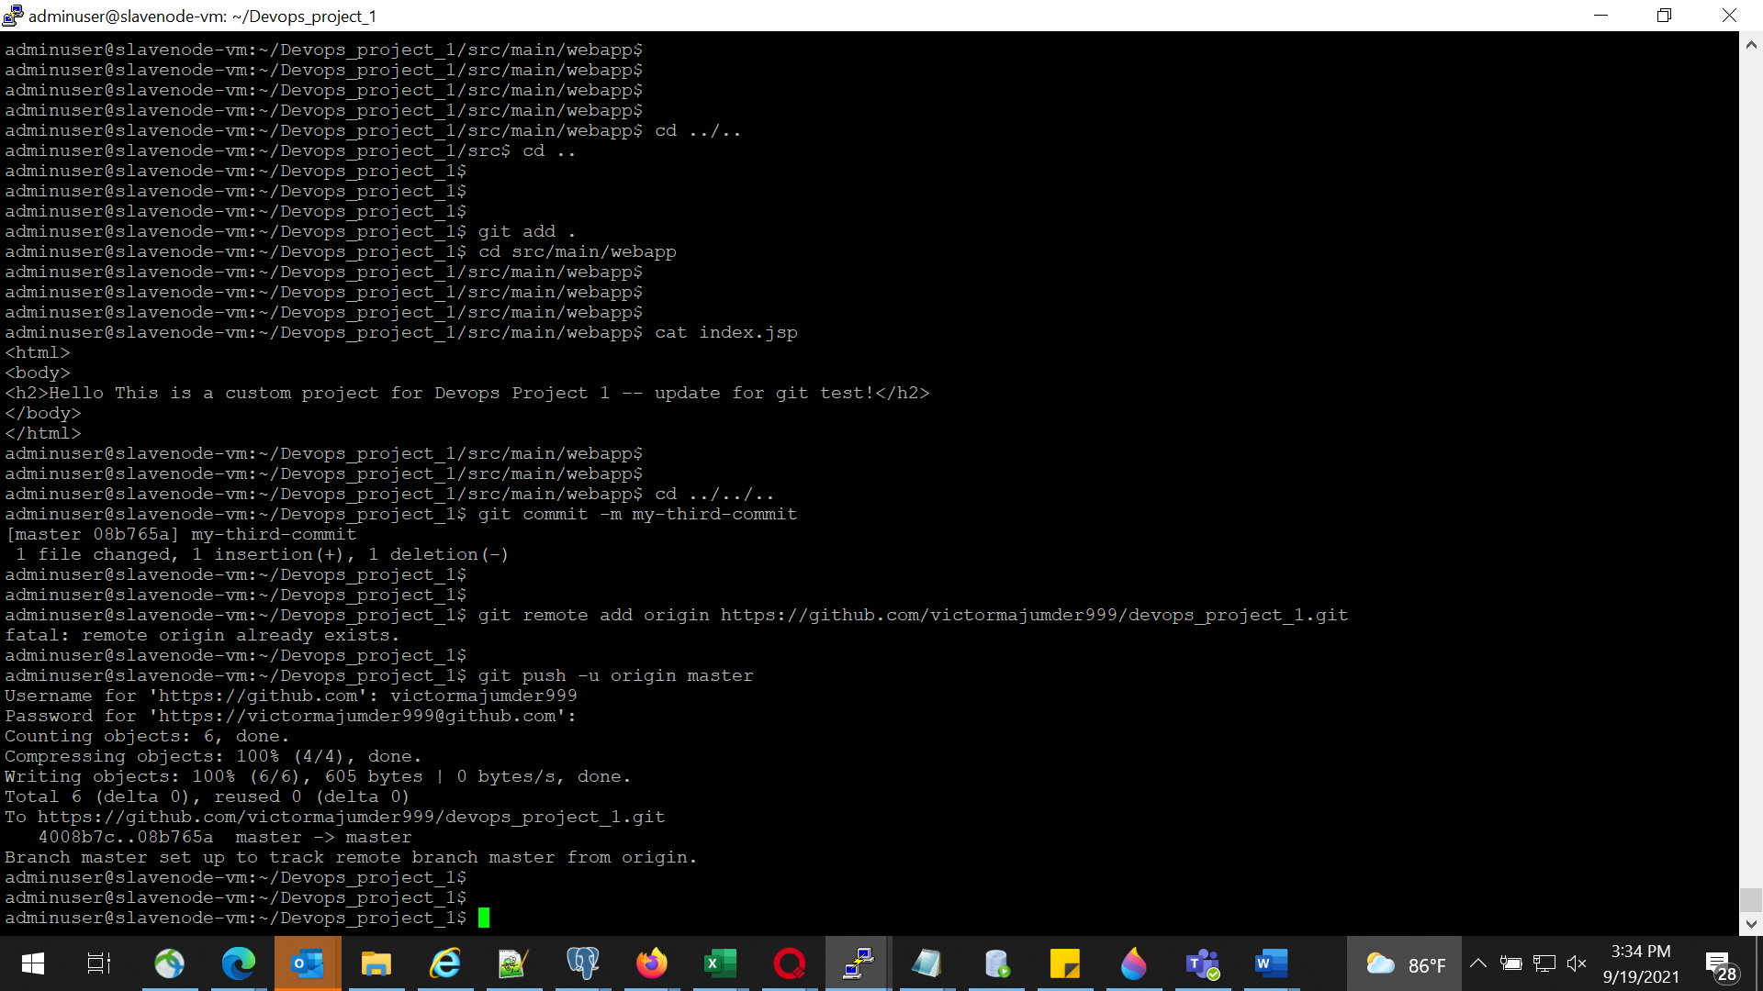

## Check for the change in remote Repo

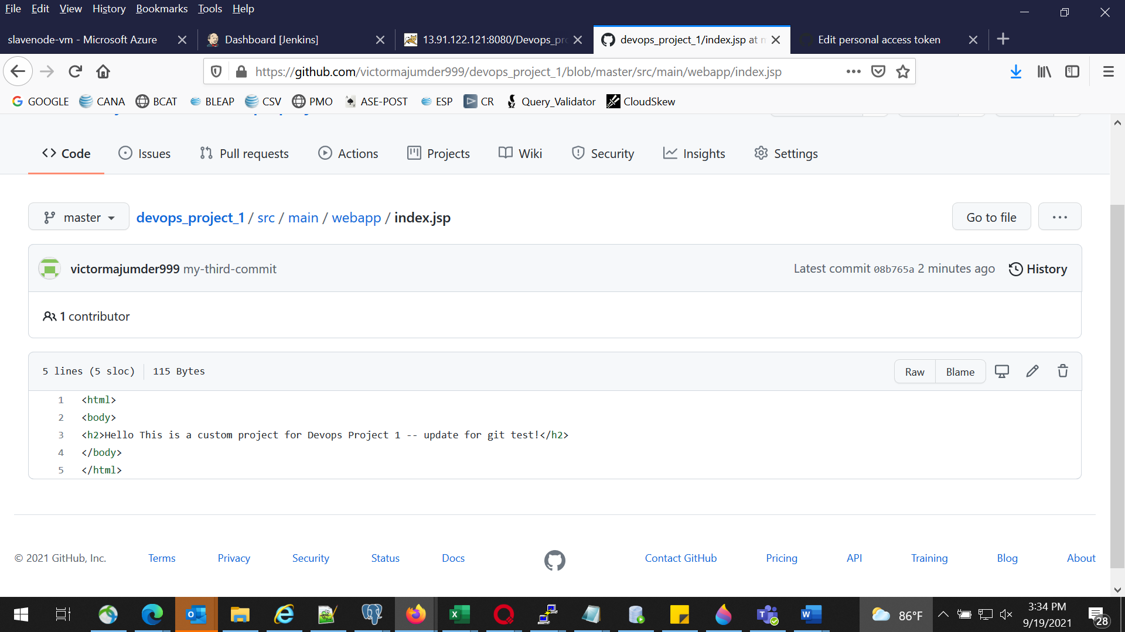

# Part 2 – Phase 5

## In build server configure Ansible manually

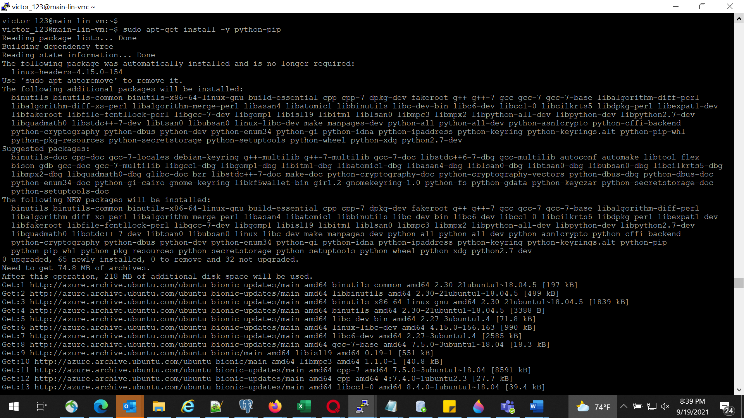

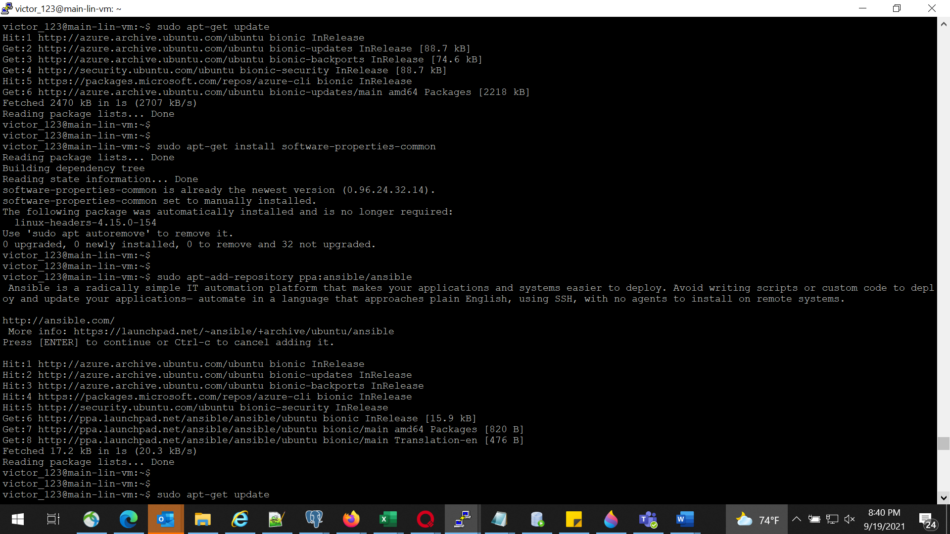

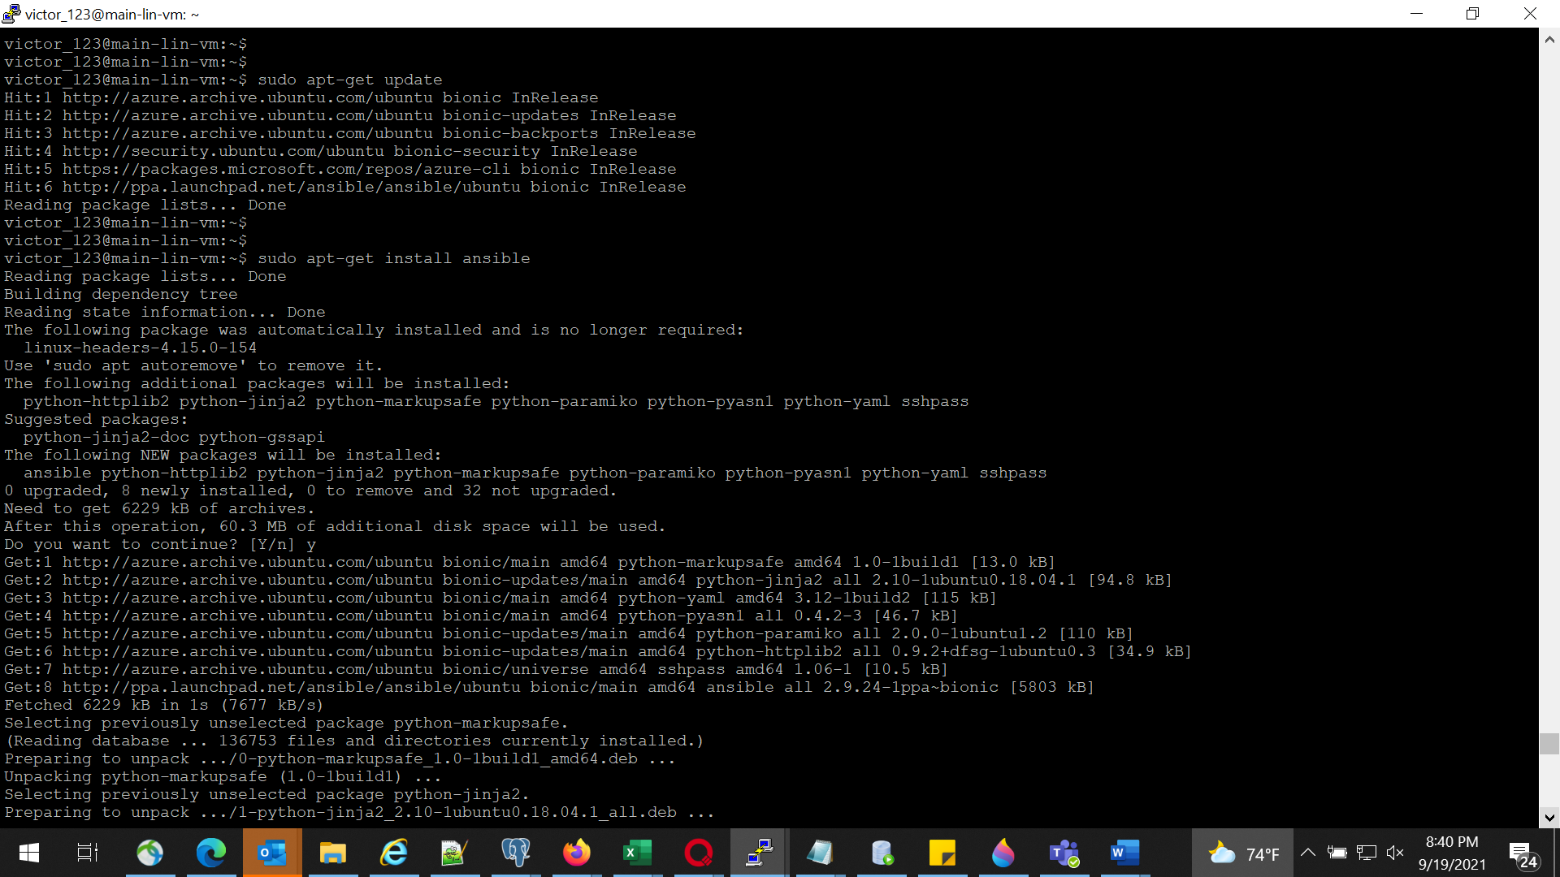

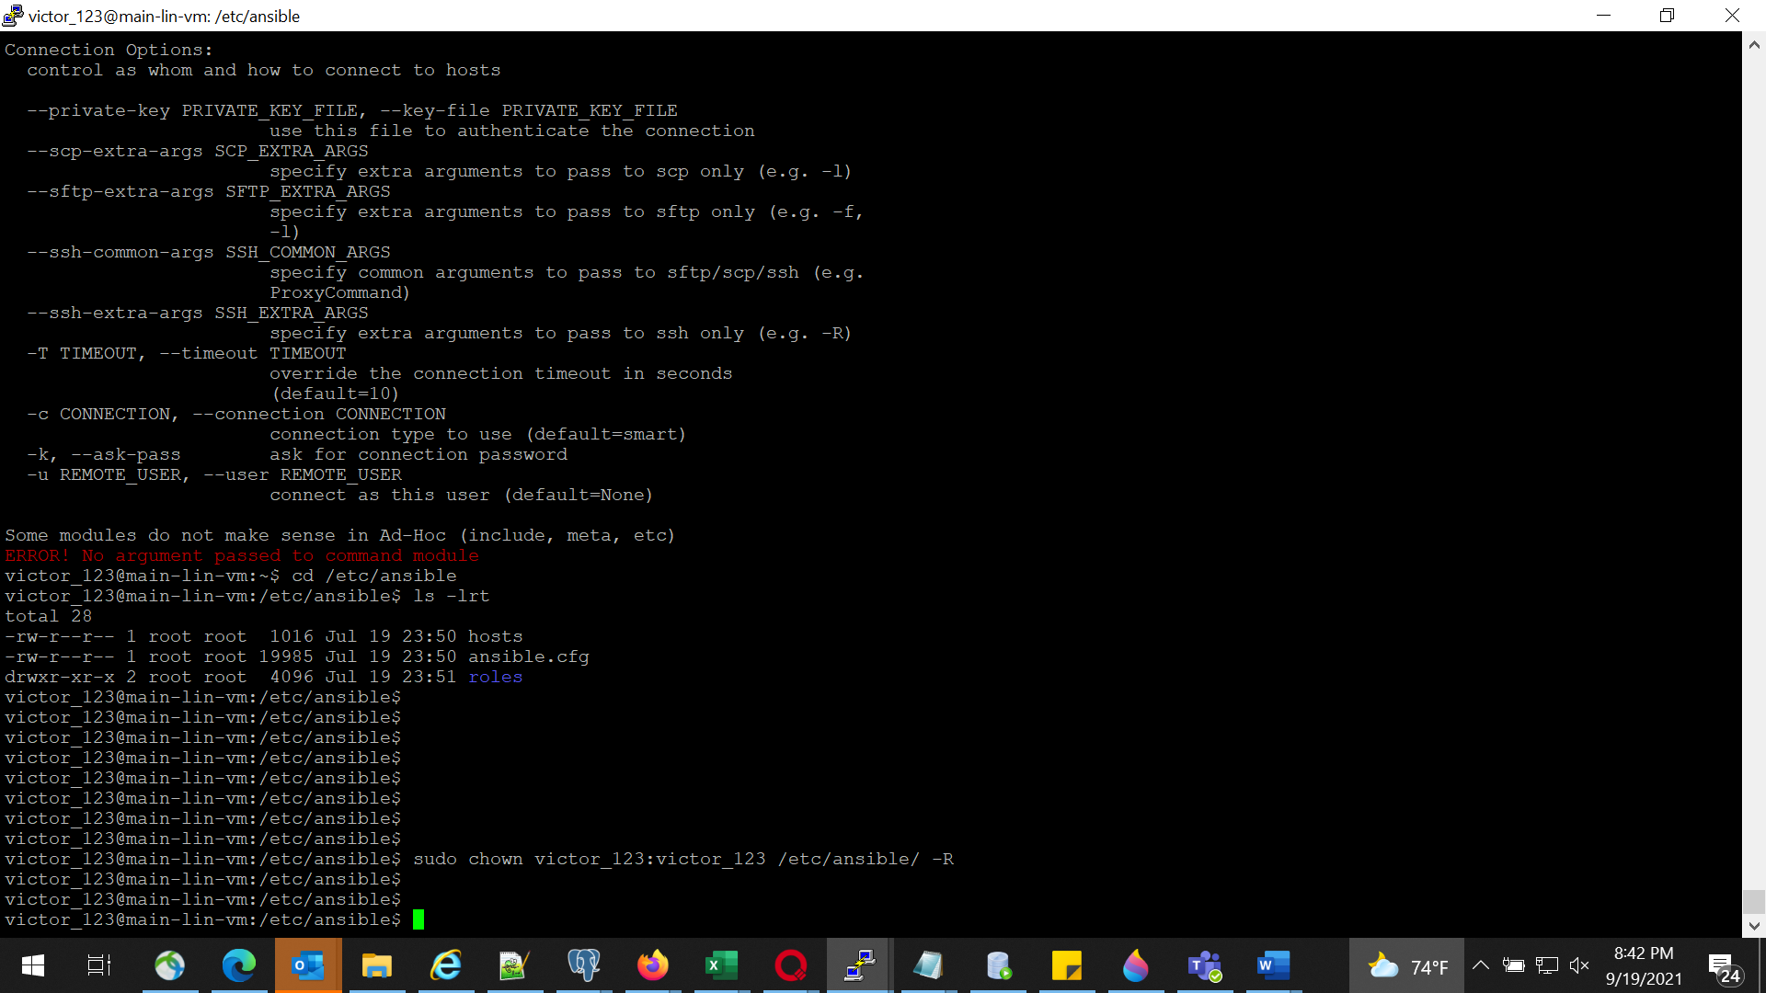

## Modify ansible.cfg to use hosts file as inventory

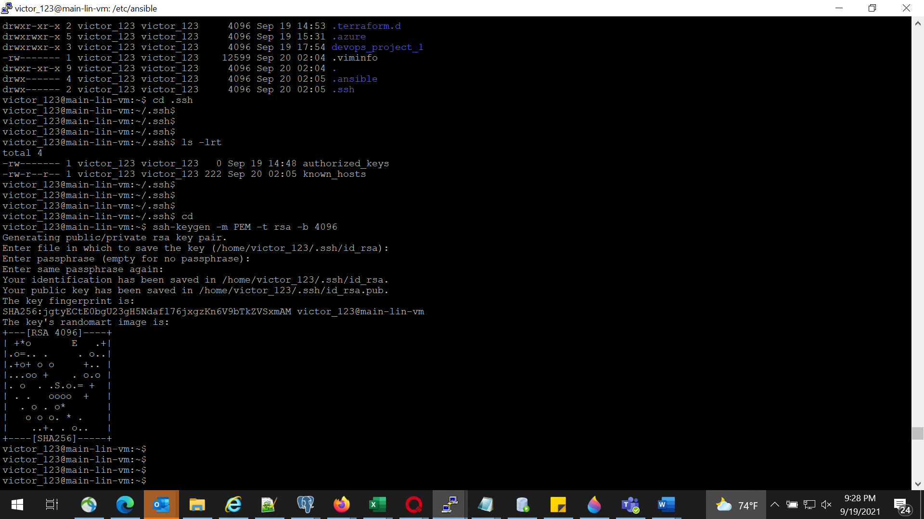

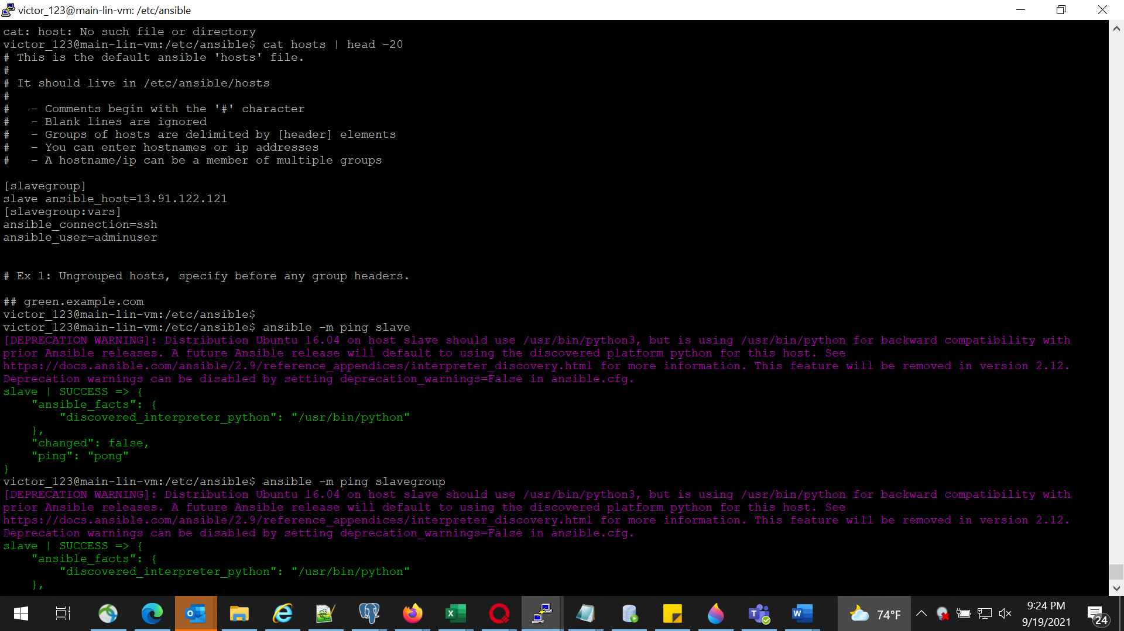

## install python-pip in ansible server

python-pip was already installed by terraform

## Using PIP install azure modules in Ansible server

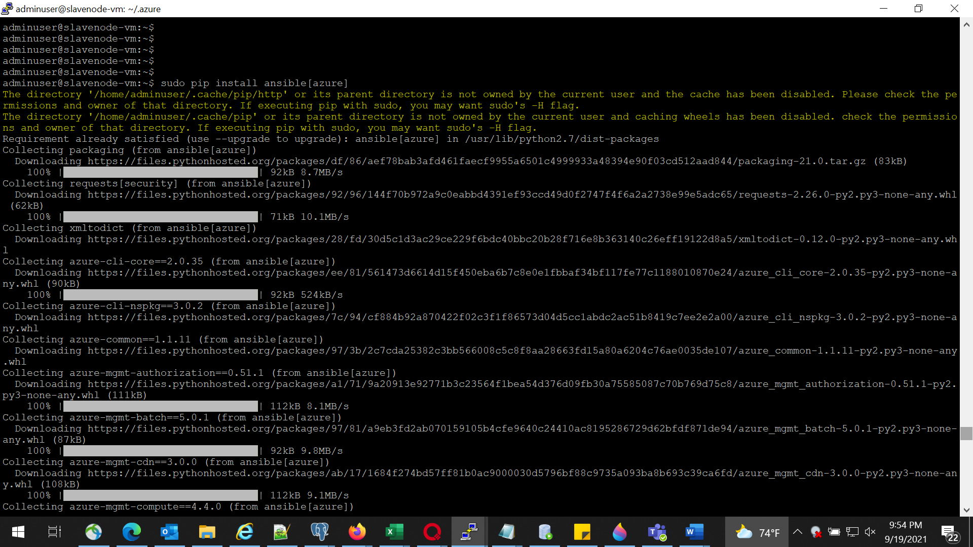

## Use the same service Principle created for terraform for ansible to get authenticated to Azure

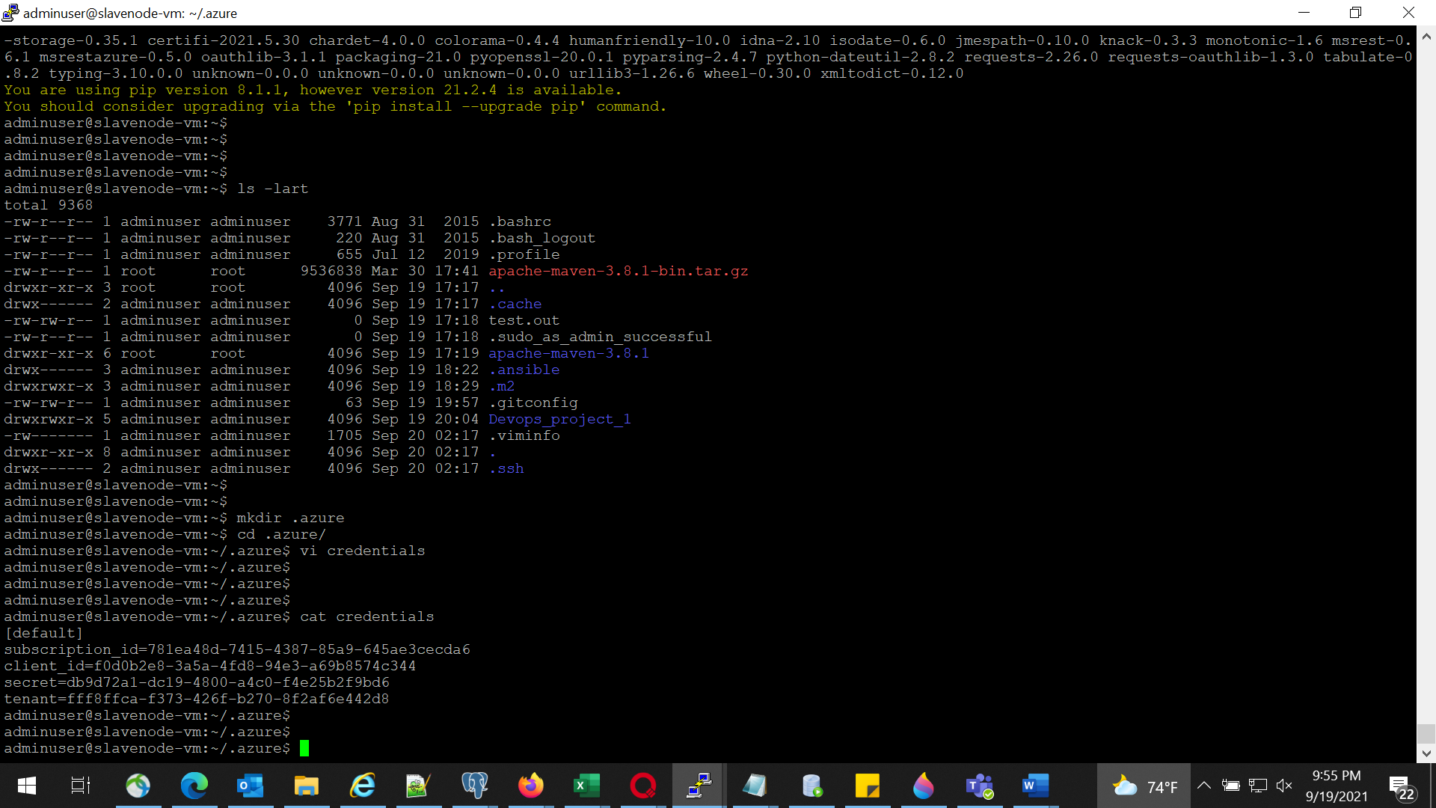

# Part 2 – Phase 6

## Push playbook1, playbook2 and shell scrip to Remote Git repo created in Phase3

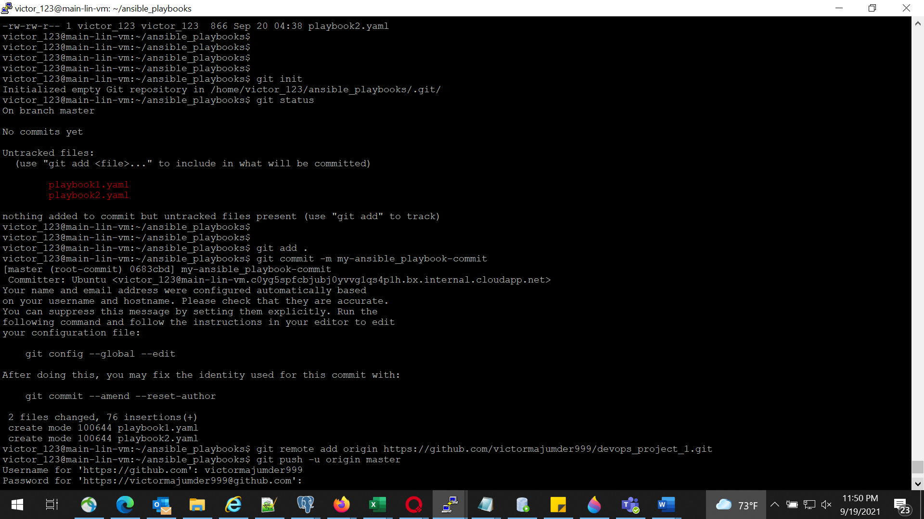

# Part 2 – Phase 7

## From Build server run the playbook1,playbook2 and shell script to test for the required result

